**Palo alto clientless vpn**

Derek Liu Cybersecurity Period 5

**Setting Up a Clientless VPN***Derek Liu*

Purpose

The purpose of this lab is to set up a clientless remote access VPN. With a clientless VPN, the remote should be able to set up a VPN tunnel to a network and access internal resources by typing an address into the search bar and entering credentials.

Background Information

A clientless VPN or browser-based VPN allows for users to access internal resources in a network through a web browser without the need to install software or client-based applications.

Clientless VPNs are useful when resources need to be accessed from a remote location easily and quickly and from any device. This can be helpful for those working on a public or shared computer that do not have administrative privileges to install software on their devices.

However, clientless VPNs are limited in terms of performances and functionality compared to VPN clients as they are only able to access web-based applications. They don’t offer advanced security protocols or features such as split tunneling.

Clientless VPNs also are not as secure compared to a traditional VPN since they do not offer advanced security features such as Open VPN, SSTP, or two factor authentication. Another shortcoming is its reliance on web browsers which have a lot of possible vulnerabilities due to their complexity.

Clientless VPNs are also not able to provide the same amount of control and visibility as a traditional VPN client which means that potential threats are harder to detect.

Lab Summary

In this lab, we set up a clientless remote access VPN with a Palo Alto 220. Functionality was tested by connecting to the VPN and accessing an internal web server that is not reachable from the internet.

Network Diagrams with IP

(note: The web server was set up with a windows computer running an Apache web server with XAMPP).

Configurations

Step 1: Create a SOHO and remote access configuration. Refer to labs Remote Access VPN and SOHO Setup if needed.

Step 2: go to dynamic updates. Download and install the GlobalProtect Clientless VPN

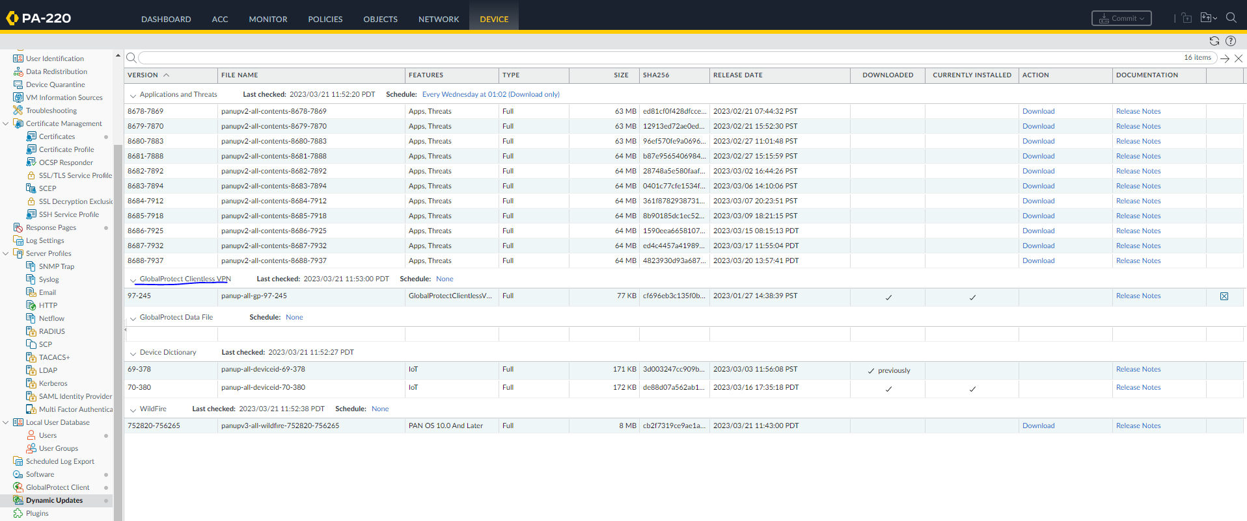

Step 3: go to Network, Clientless Apps, and configure the following

Step 4: go to DNS proxy and configure the following

Step 5: Go to portals and configure the following (most of the tabs were configured in the previous lab)

Step 7: go to Clientless VPN and configure the following

Step 8: go to applications and configure the following

Step 9: go to Crypto Settings and configure the following

Step 10: go to Agent, Client Settings, and IP pools. We changed the IP pool so the devices will be on the same subnet.

Step 11: access the remote user and go to the IP address of the WAN interface

Step 12: Open the configured applicaiton

Step 13: our web server

Problems

The original problem we ran into was we forgot to install the clientless VPN on the Palo Alto firewall, so the feature originally refused to activate. This was solved by going into dynamic updates and downloading and installing the clientless VPN feature.

Conclusion

In this lab, we configured a clientless VPN which is a VPN that establishes a connection with a web browser without the need to install any software or client. The process is very streamlined and simple on the Palo Alto and was completed with relatively few problems.